Crucible

System Requirements Specification

# Contents

1. Introduction
   1. Purpose of This Document
   2. References
   3. Purpose of the Product
   4. Product Scope
2. Functional Requirements
3. Non-Functional Requirements
4. User Interface
5. Deliverables
6. Open Issues

Appendix A – Agreement Between Customer and Contractor

Appendix B – Team Review Sign-of

Appendix C – Document Contributions

## Introduction

## Purpose of this document

## Purpose of this document is to let the engineers and users of this product view the goals and functionality of Crucible. Within this document it will state the intended features and implementation of those features to be able to satisfy the requirements of this application.

* 1. References

Title: How to Make a Fitness App and Make Money 2021

Author: Addevice

<https://addevice.io/blog/how-to-create-a-workout-app-detailed-guide/>

Title: The Swift Programming Language

Author: Apple

https://docs.swift.org/swift-book/GuidedTour/GuidedTour.html

* 1. Purpose of the Product

Users will be able to log in their daily workout, track their nutrition, and share their progress with friends. The product will also have push notifications, that will remind the user to keep a consistent workout schedule, log their daily workouts, and reminder for consistent healthy lifestyle choices, e.g. drinking more water.

* 1. Product Scope

The system shall include systems that will allow users to track nutritional, exercise and also act as a medium for social interaction within the application. Within this application it shall have integration for a graphical display of information for both nutrition and exercise. In addition, this system will take information from the user’s input and be able to display the data accurately in the graphical display. The application will also be able to use this information that the user provides to create goals, and provide a report using the information that has been collected.

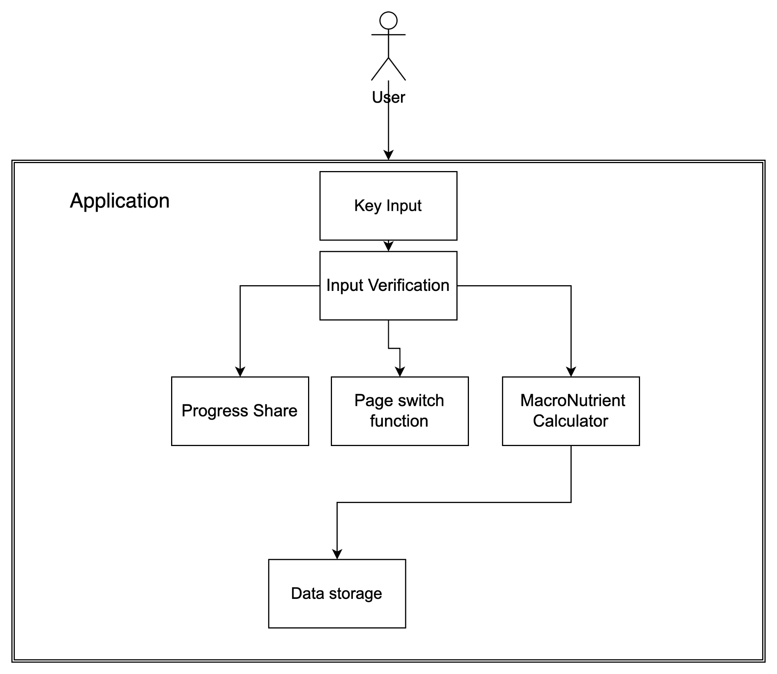

## Functional Requirements

| Case Number | 2.1 |
| --- | --- |
| Name | Key input |
| Summary | This function takes user information about the food and stores it within the nutrition section or inputs weightlifting information within the exercise |
| Priority | A level 5 priority because this is a key feature that is necessary for usage |
| Preconditions | That the user has an account within the Crucible app  The information of previous meals for the day  The information within the weightlifting section |
| Postconditions | It adds the information for the food that the user has input if it is within the food portion or the weightlifting information within the exercise section |
| Primary Actor | The end user |
| Trigger | The user selects the add food choice within the nutrition section or the user selects to add an exercise within the weightlifting portion. |
| Main Scenario | 1. The user selects to add food 2. The user shall input information about the food or exercise 3. The app will update the information about the exercise or the meals |

| Case Number | 2.2 |
| --- | --- |
| Name | Progress Share |
| Summary | This function will allow users of the application to share their progress with others |
| Priority | This is a 1 because it is an important function to be implemented with social media portion |
| Preconditions | The data from both weightlifting and nutrition portions of the application  The connection with possible social media or other aspects of their phone |
| Postconditions | That the user has shared their progress with the application to others |
| Primary Actor | The end user |
| Trigger | The user either choose to share a milestone or their monthly report |
| Main Scenario | 1. The end user has decided to share their progress with others 2. Then the end user selects to share their progress and what method they would like to use |

| Case Number | 2.3 |
| --- | --- |
| Name | The MacroNutrient Calculator |
| Summary | This function will take information from the stored food and meals and showcase what the end user should eat |
| Priority | This is a 4 because |
| Preconditions | The food that the person has input for the day  The amount of suggested macronutrients for the end user |
| Postconditions | This updates the projected macronutrients that is the suggested amount that the person should consume |
| Primary Actor | The End User |
| Trigger | This updates whenever the end user inputs food into the application |
| Main Scenario | 1. The user has input the food that they have consumed 2. The information from the input is compared against the suggested macronutrients 3. The function calculates the new projected suggested macronutrients |

| Case Number | 2.4 |
| --- | --- |
| Name | Input Verification |
| Summary | This function will verify both the input numbers that the user enter but also the name of the food or exercise |
| Priority | This is a 5 because it is critical to sanitize user input |
| Preconditions | The information that the user has attempted to insert |
| Postconditions | The information has been input into the data pool |
| Primary Actors | The end user |
| Trigger | The user has attempted to enter information into nutrition or fitness portions of the application |
| Main Scenario | 1. The user has input information 2. The name of the food/exercise has been error checked and sanitized 3. The number are error checked 4. The information is added to the selected portion of the application |

| Case Number | 2.5 |
| --- | --- |
| Name | The page switch function |
| Summary | The ability to swap between the different pages of the fitness application |
| Priority | 5 |
| Preconditions | The user has the application installed  If the user has any preferences set within the application  If the user has any data that needs to be shown for that page |
| Postconditions | Changes the current frame of the application to the proper one that the user has selected  Showcases the relevant information for the page that the user has selected |
| Primary Actor | User |
| Trigger | The User has elected to change the current page for a different one |
| Main Scenario | 1. The user wishes to select a different page 2. The user uses the application interface to change the page 3. The page will change and showcase the relevant information |

| Case Number | 2.6 |
| --- | --- |
| Name | Data Storage |
| Summary | This function will store the information that the user has input into the application |
| Priority | 5 |
| Preconditions | There is data to input  This data is proper data and has been sanitized |
| Postconditions | The data has been stored within the database and is ready for usage |
| Primary Actor | The User |
| Trigger | The user attempts to insert data |
| Main Scenario | 1. The user attempts to add a data point 2. The data is then sanitized 3. The data is added to the database 4. The database is ready to be used for retrieval for individual showcase or a graphic |

## Non-Functional Requirements

| Case Number | 3.1 |
| --- | --- |
| Name | Graph Creation |
| Summary | Creates the graph for the end user to visualize their progress |
| Priority | 3 |
| Preconditions | The information that the graphic is showcasing (Nutritional or Fitness) |
| Postconditions | Creates a new graph for the portion of the application it is on |
| Primary Actor | End User |
| Trigger | The user has added enough information to create a line graph of progress |
| Main Scenario | 1. The user has reached 3 points of data 2. This data is used to create a new graph to showcase the user’s progress 3. The graph is now showing on the page that the data corresponds to |

| Case Number | 3.2 |
| --- | --- |
| Name | Graphical Update |
| Summary | Adds new points to a created graph |
| Priority | 3 |
| Preconditions | That a graph has already been created  The user has added new input information for that the graphic is showcasing |
| Postconditions | The graphic has been updated to reflect the new data |
| Primary Actor | End User |
| Trigger | The user has added a new input data into the application that is being display within a graphic |
| Main Scenario | 1. The user adds new data 2. The graphic has to accommodate the new data point and add it to the end 3. The graphic is displayed to the end user |

| Case Number | 3.3 |
| --- | --- |
| Name | Daily Reminders |
| Summary | The application shall remind users to drink water, or exercise |
| Priority | 2 |
| Preconditions | This will take into account the amount of time the user uses on each portion of the application  It will also take into account the amount of time since the last data entry |
| Postconditions | It will provide the user with a push notification and also reset the timer |
| Primary Actor | Input Time scheduler |
| Trigger | The time frame for an input will soon reach a full twenty four hours |
| Main Scenario | 1. The user has not added any new inputs into the system for nutrition or exercise 2. The application provides a reminder in the form of a push notification 3. The user either opens and adds new input resetting the timer or disregards the timer all together |

| Case Number | 3.4 |
| --- | --- |
| Name | Monthly Report |
| Summary | The application after a month of use every month shall provide the user with a progress report |
| Priority | 4 |
| Preconditions | How long the user has used the application  The data for the month  Any significant progress that has been calculated for the user |
| Postconditions | Provides a graphic and shows the user how much progress that they have done over the course of the month compared to the start of the month |
| Primary Actor | User |
| Trigger | The amount of time that the user has had the application has exceeded one month |
| Main Scenario | 1. A user has been using the application 2. The application pulls data from their month’s progress 3. It processes the information and then will display it to the end user 4. This can be shared or ignored by the user 5. The timer for the month restarts |

## 

| Case Number | 3.5 |
| --- | --- |
| Name | Timer |
| Summary | This will keep track of the amount of days that has passed since the last monthly reset |
| Priority | 4 |
| Preconditions | This function shall know the amount of time since the last month in days  What day the timer was initially started |
| Postconditions | The Timer function resets at the beginning at each moth |
| Primary Actor | The timer function |
| Trigger | The timer reaches the number of days within that month |
| Main Scenario | 1. The user downloads the crucible application 2. The Timer function is used to let the monthly report and daily reminders functions when to be sent 3. Reset on the end of the month |

## 

## User Interface

See “User Interface Design Document”

## Deliverables

A ZIP file containing the following:

* Systems Requirement Specification
  + PDF
  + Submit Date: 10/20
* System Design Document
  + PDF
  + Submit Date: 10/20
* User Interface Design Document
  + PDF
  + Submit Date: 10/28
* User Manual
  + PDF
  + Submit Date: With completed application
* Administrator Manual
  + PDF
  + Submit Date: With app
* Copies of all Biweekly Status Reports
  + PDF
  + Submit Date: Every 2 weeks
* All source code
  + Github
  + Submit Date: When Project is turned in
* The executable program
  + Github
  + Submit Date: When Project is turned in
* Any other software required for installation and execution of the delivered program.
  + Github
  + Submit Date: When the Project is turned in

## Open Issues

## Michael not having an apple computer

* Cloud integration for our graphical user interface and also storing user information
* Method of testing the portion of the application and the thoroughness of those tests
* Amount of time that each will coding group spend on the project
* The integration of multiple different pages that will require the ability to transition between pages quickly and easily,
* The coding and integration of accessibility tools that can change text color, and increase text size
* The creation of algorithms that allow for a seemingly random types of quests that are given to the user
* The display of graphs and user interfaceable features that users will see when using the application

## Appendix A – Agreement Between Customer and Contractor

## The team and our customer are agreeing to have a fitness app created that will allow the user to track their exercise and see how much calories they ate during the day. The app will be secure and users can share their workouts with other people who use the software securely. There will be no transaction between the user and the team without notifying the user and asking them to pay for our app. Also, the customer has to approve the use of their workouts being tracked when on the fitness application. The customer will receive a working app when they download it and we can address any issues they have after they use the features that we have.

## Our group knows that there could be future additions to this document and parts of the app may not be developed. In the event that we have to change this form we will notify the customer and make sure they approve the new requirements we have and would work with them to have the best application we can build. The way we will make sure they participate in all aspects of the development process and also be notified of any and all changes that the team may wish to implement. In addition, the Crucible project team will be subjected to create update reports should the requirements change in a vast manner that shall be produced in a timely manner. Should the customer require any modifications of the system that they wish to implement they can submit a written document in which it shall entail the details and specifications of the changes that they will desire. However, these changes may or may not be approved by the Crucible team under the circumstances of cost, and time. However, should the change be necessary it shall be implemented with a new timeframe of development and release to the customer. In addition, should the change be unfeasible to implement within the release timeframe, an update can be developed for the Crucible application and this update will be released after the initial agreed upon release date, however the update shall take the precedence with suggested changes for the application. Lastly, both parties must agree upon large changes within the application. This is to mitigate the amount of time that is required to develop the application. In addition, the development team has oversight as well as responsibility of their respective domains and development of the Crucible application.

## Signing below acknowledges the facts that are denoted above and I do accept on behalf of myself or the company I represent has read and approves of everything outlined above.

## Customer Signature: X_____________________________________________________

## Customer Comments:

## Appendix B – Team Review Sign-off

All Members of the Crucible team have read and reviewed this document and have agreed on the content and format.

I [Miles Wilson](mailto:milesw1@umbc.edu) do affirm that I have read and understand the contents of this document and as well do actualize the fact that this document will contain information that declares what is expected of myself and my teammates.

X_____________________________________________________ Date:_____________

I [Michael Duong](mailto:mduong2@umbc.edu)do affirm that I have read and understand the contents of this document and as well do actualize the fact that this document will contain information that declares what is expected of myself and my teammates.

X_____________________________________________________ Date:_____________

I [Aryan Singh](mailto:arysin1@umbc.edu)do affirm that I have read and understand the contents of this document and as well do actualize the fact that this document will contain information that declares what is expected of myself and my teammates.

X_____________________________________________________ Date:_____________

I [Tommy Stinson](mailto:tstinso1@umbc.edu) do affirm that I have read and understand the contents of this document and as well do actualize the fact that this document will contain information that declares what is expected of myself and my teammates.

X_____________________________________________________ Date:_____________

I, [Jason Garcia Solorzano](mailto:jgarcia8@umbc.edu), do affirm that I have read and understand the contents of this document and as well do actualize the fact that this document will contain information that declares what is expected of myself and my teammates.

X_____________________________________________________ Date:_____________

## Appendix C – Document Contributions

This section holds the individual contributions of each team member and estimation of what percentage that each member has contributed to the writing.

Tommy - Section 2 20%, Section 3 20%, Section 5 100%

Miles - Cover page 100%, Table of contents 100%, Section 1.4 diagram

Michael - Section 6 100%, Section 1.4, Section 2 20%, Section 3

Jason - Introduction 1.1, 1.2 20%, Section 2 20%

Aryan - 20% Section 2, 20% Section 3